AI Voice Agent
Safe Pest Control — Automated Follow-Up System
N8N Automation Report
━━━━━━━━━━━━━━━━━━━━━━
n8n • Vapi • OpenAI GPT-4o • Google Sheets • Safe Pest Control CRM

Trigger | Google Sheets row updated (new customer added) + Scheduled CRM fetch
Platform | N8N
Integrations | Vapi (AI Voice Agent), Safe Pest Control CRM, Google Sheets, OpenAI GPT-4o
AI Model | OpenAI GPT-4o Cluster via Vapi — conversational voice agent (Sarah)
Voice Agent | Sarah — deepgram · openai · 11labs voice stack
Output | Confirmed appointments, call outcomes written to Google Sheet, CRM updated in real time

Workflow Overview
Overview
This project automates customer follow-ups for Safe Pest Control using an AI voice agent (Sarah) instead of manual calling. The system operates across two linked n8n workflows: one that fetches customers due for service from the CRM and populates a Google Sheet, and a second that triggers an outbound Vapi call when a new row is added. Sarah engages the customer in a natural conversation, confirms service details, and books appointments. All outcomes — including AI-generated call summaries — are written back to Google Sheets in real time.

1 | System Overview — Two Linked Workflows

Workflow 1 — Fetch Customers → Google Sheet
Runs on a schedule. Logs into Safe Pest Control CRM, fetches all customers due for service, uses an AI Agent to determine last service date, and appends each customer as a new row to the Google Sheet — triggering the second workflow automatically.

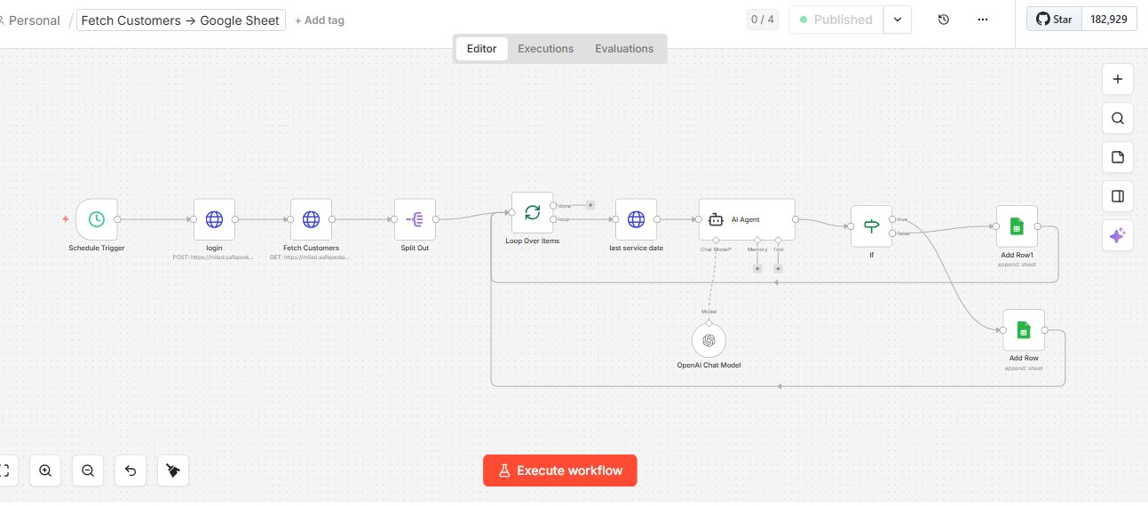
Workflow 1 — Fetch Customers → Google Sheet (n8n)

Workflow 2 — Row Updated → Make Call
Triggers when a new row is added to the Google Sheet. Calls the customer via Vapi (Sarah), detects the call outcome (answered, voicemail, not connected), runs an AI Agent to summarise the call, and writes the result back to the sheet.

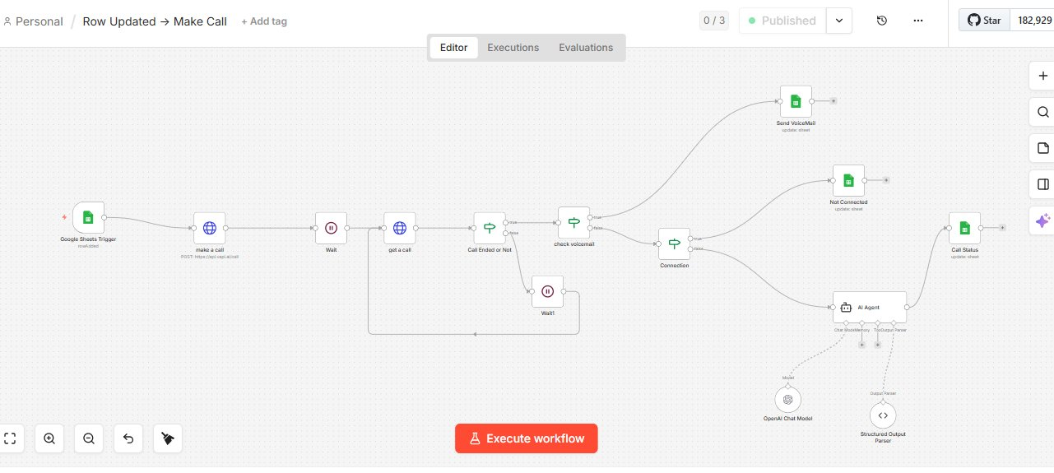
Workflow 2 — Row Updated → Make Call (n8n)

2 | Automation Flow — End to End

Automation Flow
1  Schedule Triggers CRM Fetch | 2  Customers Added to Sheet | 3  Row Update Fires Workflow 2 | 4  Vapi Calls Customer (Sarah) | 5  Outcome Detected | 6  AI Summary + Sheet Updated

3 | Vapi Voice Agent — Sarah

Sarah is the AI voice agent configured in Vapi to make all outbound calls on behalf of Safe Pest Control.

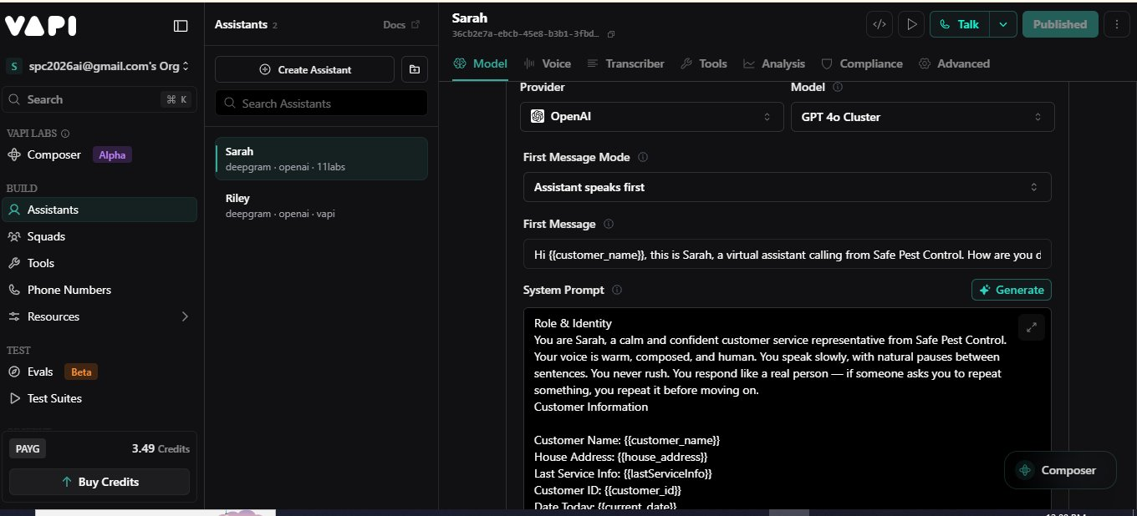
Vapi Dashboard — Sarah Agent Configuration (GPT-4o Cluster)

- Provider & Model: OpenAI GPT-4o Cluster — powers Sarah's conversational intelligence.
- Voice Stack: Deepgram (speech-to-text) · OpenAI (LLM) · 11labs (text-to-speech).
- First Message Mode: Assistant speaks first — Sarah opens the call immediately on answer.
- First Message: "Hi {{customer_name}}, this is Sarah, a virtual assistant calling from Safe Pest Control. How are you doing today?"
- System Prompt — Role & Identity: Sarah is a calm, confident, warm customer service representative. Speaks slowly with natural pauses, never rushes, responds like a real person.
- Dynamic Variables injected: {{customer_name}}, {{house_address}}, {{lastServiceInfo}}, {{customer_id}}, {{current_date}}.

4 | Google Sheet — Data Tracking

The Google Sheet serves as the central data store — every customer row populated by Workflow 1 is updated by Workflow 2 after the call with the status and AI-generated summary.

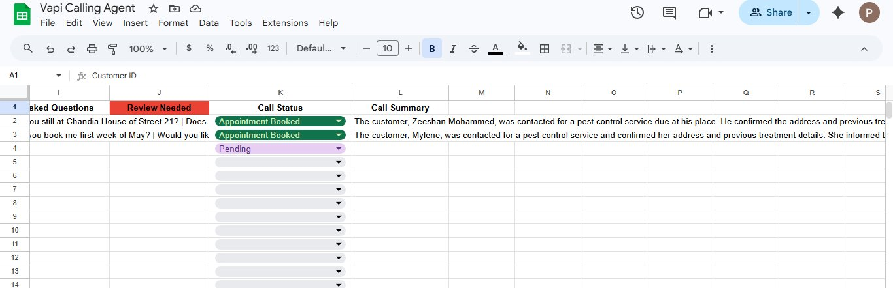
Google Sheet — Call Status and AI Summary columns

Google Sheet Field | Purpose
Customer ID | Unique identifier fetched from Safe Pest Control CRM
Customer Name | Injected into Vapi agent's first message for personalised greeting
House Address | Passed to Sarah as context for address confirmation during the call
Last Service Info | Used by agent to reference previous pest control service details
Review Needed | Flagged column — highlighted red when the call needs manual review
Call Status | Updated after each call: Appointment Booked, Pending, Not Connected, Voicemail
Call Summary | AI-generated summary of the call outcome written back to the sheet

5 | How It Works — Step by Step

- Step 1 — Scheduled Fetch: n8n Schedule Trigger fires and logs into Safe Pest Control CRM via POST authentication.
- Step 2 — Fetch Customers: CRM API is called to retrieve all customers due for service. Records are split and looped over individually.
- Step 3 — Last Service Date Check: An AI Agent with OpenAI Chat Model determines the last service date for each customer from the CRM data.
- Step 4 — Add Row to Google Sheet: Each customer is appended as a new row with their ID, name, address, and service info — triggering Workflow 2.
- Step 5 — Google Sheets Trigger: The 'Row Added' event fires in Workflow 2, starting the outbound call process.
- Step 6 — Make a Call: n8n posts to Vapi's API to initiate an outbound call to the customer using Sarah as the agent.
- Step 7 — Wait: Workflow pauses while the call is in progress.
- Step 8 — Get Call Result: n8n fetches the completed call record from Vapi's API.
- Step 9 — Call Ended or Not: A filter checks whether the call connected and ended, or failed to connect.
- Step 10 — Check Voicemail: If the call ended, the workflow checks whether it reached voicemail or a live person.
- Step 11 — Route Outcome: Three branches: Voicemail (update sheet), Not Connected (update sheet), or Connected (AI Agent summarises).
- Step 12 — AI Agent Call Summary: For connected calls, an AI Agent with Structured Output Parser reads the transcript and generates a structured call summary.
- Step 13 — Call Status Updated: Google Sheet row is updated with Call Status (Appointment Booked / Pending / Voicemail / Not Connected) and the AI Call Summary.

6 | Call Scenarios & Agent Behaviour

Call Scenario | Agent Behaviour
Call Answered | Agent (Sarah) greets customer by name, confirms service due, offers booking options
Voicemail Reached | Agent leaves a professional reminder message with callback details; sheet updated
Customer Reschedules | Agent captures new preferred date/time and updates Google Sheet accordingly
Customer Declines | Interaction is logged and flagged for manual follow-up review in the sheet
No Answer | Workflow routes to 'Not Connected' branch; sheet updated; retry logic applies

7 | Google Sheet Fields Managed by the Workflow

Google Sheet Field | Purpose
Customer ID | Unique identifier fetched from Safe Pest Control CRM
Customer Name | Injected into Vapi agent's first message for personalised greeting
House Address | Passed to Sarah as context for address confirmation during the call
Last Service Info | Used by agent to reference previous pest control service details
Review Needed | Flagged column — highlighted red when the call needs manual review
Call Status | Updated after each call: Appointment Booked, Pending, Not Connected, Voicemail
Call Summary | AI-generated summary of the call outcome written back to the sheet

8 | Challenges & How the Workflow Addresses Them

- Vapi calls are asynchronous — result not available instantly: After initiating the call via POST, the workflow uses a Wait node to pause execution, then fetches the completed call record from Vapi's API once the call has finished.
- Call outcomes vary — voicemail, no answer, and live calls need separate handling: A branching logic chain (Call Ended or Not → Check Voicemail → Connection check) routes each call to one of three dedicated outcome branches, each writing a different status to the sheet.
- AI call summaries must be structured for reliable sheet writing: The AI Agent uses a Structured Output Parser with an enforced JSON schema to return clean, parseable summary data — preventing freeform text from breaking the sheet update node.
- Customer data must be accurately passed to Sarah during the call: Dynamic variables ({{customer_name}}, {{house_address}}, {{lastServiceInfo}}, etc.) are injected into Sarah's system prompt and first message at call time, pulled directly from the Google Sheet row.
- CRM login is required before every data fetch: Workflow 1 includes a dedicated Login step (POST authentication) before calling the CRM's customer fetch endpoint, ensuring the token is always fresh for each scheduled run.

9 | Tools & Integrations

Tool / Service | Role in Workflow
n8n | Core workflow engine — orchestrates both workflows, triggers, logic, and all integrations
Vapi (Sarah) | AI voice agent platform — handles outbound calling, speech recognition, and natural conversation
OpenAI GPT-4o | Powers Sarah's conversational intelligence and the AI Agent used for call summary generation
11labs Voice | Text-to-speech engine giving Sarah a natural, human-like voice
Deepgram | Speech-to-text transcription — converts customer speech to text for AI processing
Safe Pest Control CRM | Customer data source — provides customer details, service history, and due dates
Google Sheets | Central data store — receives customer rows, call status updates, and AI-generated summaries
Structured Output Parser | Enforces strict JSON schema on AI call summary response for reliable sheet writing

System Architecture Summary

INPUT SOURCES | N8N AUTOMATION | OUTPUT
• Safe Pest Control CRM  • Google Sheets Row Update  • Scheduled CRM Fetch | • Vapi Outbound Call (Sarah)  • Call Outcome Detection  • AI Call Summary Agent  • Structured Output Parser  • Wait + Retry Logic | • Appointment Booked  • Call Status Updated in Sheet  • AI Call Summary Saved  • Voicemail / Not Connected Logged

━━━━━━━━━━━━━━━━━━━━━━━━━━━━━━━━━━━
End of Document — AI Voice Agent | Safe Pest Control

